

**Red Raiders Emergency Instructions 2013**

A new city, a new logo, a new name. Some old problems. The former Richmond Rebels are embarking on a new page in their history, this time as the Taylorville Red Raiders. The problems to be faced, the same as any team in a rebuilding mode. We can put on the field, some of the components of a good team. However, there are serious gaps and concerns that need to be addressed. This season will be the beginning of that project. Here’s how we would like to put our resources to work:

**Starting Pitching:**

The 2013 Red Raiders feature a 7 man rotation. There will be a full season of starts from: Vargas, Wood, Beckett, Happ, and Guthrie. Laffey and Niemann, will fill in the remaining necessary starts. Arrieta and Morton will most likely be in the Minors all season. There will be instances where an early eruption of runs will force the starter to stay in until pounded out. We don’t anticipate going to the bullpen before the 3rd inning.

**Relief Pitching:**

There is a good mix of relief support available. This season the closer role goes to Chapman. His top end grade and ample innings make him the man to go to in Save situations . There will be 7 relievers active all season. With the exception of the mop-up/blow out role, all will have better grades than the Starter. Use them from the 3rd inning on, to keep the Red Raiders in the game,

Early Relievers: Typically, this will be either Badenhop (in the blow-out/mop up role), Thornton, and Myers. There should be at least 2 of this group active all season. One RHP and one LHP.

Middle Relievers: If we are are close in the game (-2 runs to ahead in the game) and its in the 4th or 5th inning, look to use any of the group of: Ondrusek, Gorzelanny, and Santiago. All have ample innings available to pitch, but are also very negative in Control. We would like to piece this group together to get the ball to the Set-Up men

Set-Up: There is a Lefty/Righty option here. Use to your greatest disadvantage. We have two LHPs in Bueno and Kirkman, the RHP in the equation is Miller. IP will have to be monitored, but this trio should cover this role.

Closer: Chapman Any Save situation. He can come in as early the 8th inning for a 4 out, or possibly, 5 out Save. He has 71 innings of Gr. 27* relief. Again, use him to your disadvantage.

General Pitching Guidelines: No starter goes more than 11.7 innings. No pitcher pitching a shut-out is removed unless the 11.7 innings condition applies. There is no requirement that a relief pitcher must come out at a certain time. For example, it is permissible for an early reliever to hand the ball over to a Set-Up pitcher, without going thru the Middle men. Use your judgment here. Play any game from + any amount of runs to -2 or -3 runs as a game the Rebels can win.

**Hitting**

Hit and Run/Steals

In general the H/R takes precedence over the straight steal and can be used at any time during the game. There are a few good base stealers on this team and they can be given the green light to steal from the 7th inning on, to get the game tying or game-winning run into scoring position. I would use Bourn, Campana, Kendrick, and Ramirez in a straight steal attempt from the 7th inning on in a game where the score is -2 to +1 and the H/R is not in order and the Catcher’s arm does not reduce the SSN below 27. Pujols and Solano can be added to this group, but with limited attempts all season, they will have to be used carefully. *We would like to see Bourn have one stolen base per series. Also, the same for Campana in series in which he is activated.*

Pinch Hitting and Pinch Running

Unless overridden by monthly instructions any bench player is available for either role. The general strategy is to use the PH in the 8th or 9th inning to get the game tying or game-winning run on base or to PR to improve the tying or winning runner’s speed. Parra and DeWitt can be used in a late game PH role (particularly in the Board game)

PH vs LHPs: Robinson, Arias or any starting player who is on the bench.

PH vs RHPs: Nieuwenhuis, Laird, Solano, and Campana or any starting player who is on the bench.

Pinch Running: Any bench player who is faster than the runner in question, particularly: Campana, Nieuwenhuis, Pastornicky and Robinson.

Runner Advancement:

With less than two outs, in all situations before the 5th inning, go with a 27+ chance (Computer Game: go any time the runner is “well around” the base). With two outs, in any inning after the 5th, with the tying or go-ahead run, attempt to score with 24+ chance. Otherwise, use the 27+ guideline. For situations that do not fit this exactly, please refer to the Adams Chart.

Sacrifice:

Sacrifice more often with the bottom 1/3 of the order (except Bourn if he is batting at the bottom of the line-up). Do not bring a PH to sacrifice. Use the Sacrifice from the 7th inning on in order to get the game tying or winning run into scoring position unless you are in the #3-#6 part of the order. Do not Squeeze.

**DEFENSE**

Holding Runners and Infield Depth:

Hold all runners with less than two outs, Exceptions: “S” runners and runners with no SBAs left, do not need to be held. Do not hold with two outs.

Infield Depth:

Play “Deep” for innings 1-5. The Rebels will go for the double play or the out at 1st, at the expense of a run scoring. Play the IF “In” from the 7th on with a runner representing the tying or go-ahead run on base. In the 6th inning, use your judgement. In tight games, play “In”, for slugfests, play “Deep”.

Defensive Replacements:

The Starters are listed on the batting orders below. For defensive substitutions, use this guideline:

C: McCann, Laird

1B: Kendrick

2B: Solano, Kendrick, Arias, Pastornicky

SS: Arias, Solano, Pastornicky

3B: Arias, Solano, Pujols, Morel

OF: Nieuwenhuis, Campana, Robinson, Kendrick, Solano, Greene

DH: Extra OF, Laird, Arias

**LINE-UPS**

Vs RHP Vs LHP

Bourn CF Bourn CF

Solano 2B Solano 2B

Hamilton RF Pujols 1B

Pujols 1B Hamilton RF

Kendrick DH Kendrick DH

Middlebrooks 3B Middlebrooks 3B

Parra LF Parra LF

Ramirez SS Laird C

McCann C Ramirez SS

Note: Check for monthly line-up changes. We will send something to our away managers by the 4th of each month.

**MINORS**

The following players will begin the season playing for the Montgomery Grays (AAA):

Campana, Robinson, Morel, Pastornicky, Niemann, Laffey, Arrieta, Morton, Bueno, Badenhop

**Waiver Draft**: Aquire Tyler Pastornicky drop Tyler Greene

**CONCLUSION**

The Taylorville Red Raiders will be playing from the computer game this season. Hand written scoresheets are not required from opposing managers. Please do not use any BBW micromanagers. *We will be e-mailing monthly line-up changes, roster moves, and any changes to these instructions.* There will be many changes during the season due to strict platooning requirements and juggling in the positions mentioned, so be sure to check for updates.

All monthly instructions supercede these instructions.

The Red Raiders are into a rebuilding mode. There are far fewer good options on this roster than we have been able to offer in the past. Please make the best decision possible for the Red Raiders within the parameters of these instructions. If a situation arises that is not covered by the instructions, please use the course of action that makes the best baseball sense. If any serious issues come up, please feel free to contact us.

Best of luck to everyone in 2013!

Bruce and Glenn Taylor

Taylorville Red Raiders

“A Baseball Tradition Since 1998”

2003, 2004, 2005, 2006, 2011 Williams Division Champions

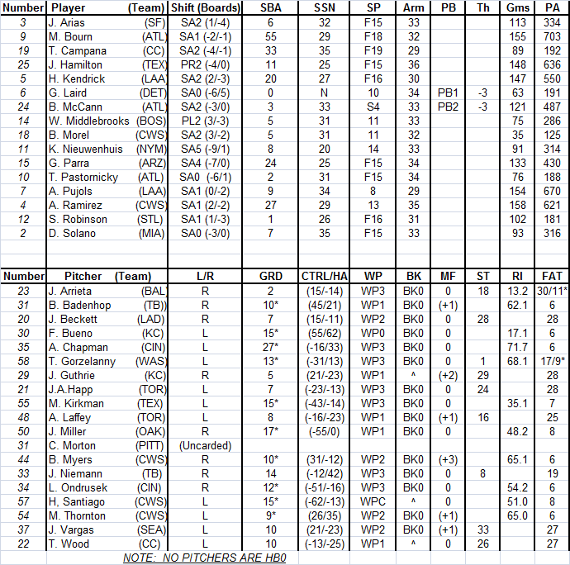



ROTATION:

